**CS 3132 Cloud Computing Lab Report (2024-25) (Jul-Dec)**

**Student Name: Aryan Vats**

**Registration ID: BT22GCS208**

**Section: C3**

**Email ID:Aryan.vats22@st.niituniversity.in**

**Assignment Date: 02-09-2024**

**Completion Date** *(when you completed the lab assignment)***:** *08-09-2024*

**1. Lab Assignment #3:** Virtualization and Application Deployment: Building a Multi-Server Environment

**Objective**: The objective of this lab is to demonstrate the process of setting up a virtualized environment using VirtualBox and deploying a multi-server configuration. Specifically, we will install and configure two application servers and one database server. Additionally, we will develop a simple login application that utilizes the resources from the two application servers and the database server. The lab aims to showcase how to access and interact with the application from both the host operating system and an external system.

**[**Note: Install three servers using VirtualBox. Use two of them to install any application server (Apache etc) and any database server (MySQL etc). Create an application (say a simple login) on the third using the other two servers. Access the application from your host OS and another system.**]**

|  |
| --- |
| **Instructions**:  **Step 1: Install VirtualBox –**   * Download and install VirtualBox from the official website: https://www.virtualbox.org/   **Step 2: Create Virtual Machines**   * Open VirtualBox and click on "New" to create a new virtual machine. * Follow the setup wizard to create three virtual machines with the desired specifications (e.g., RAM, CPU, storage). * Make sure to set up networking correctly to allow access to the application.   **Step 3: Install OS and Application Server**   * Install the desired operating system (e.g., Ubuntu, CentOS) on two of the virtual machines. * On one of the VMs, install the application server (e.g., Apache, Nginx) using the package manager of your chosen OS.   **Step 4: Install Database Server**   * On the second VM, install the database server (e.g., MySQL, PostgreSQL) using the package manager of your chosen OS.   **Step 5: Set Up the Application VM**   * On the third virtual machine, install the desired operating system and set up the application environment (e.g., LAMP, MEAN, etc.).   **Step 6: Develop the Application**   * Develop a simple login application using your preferred programming language and framework.   **Step 7: Access the Application**   * Ensure that all virtual machines are running. * Access the application from your host OS by entering the IP address of the third VM in a web browser. * Access the application from another system by entering the IP address of the third VM in a web browser on that system. |

**2. Hardware Requirement:**

* **Quad-core processor (Intel i5 or Ryzen 5 equivalent) or higher.**
* **At least 8 GB of RAM, though 16 GB is recommended to ensure smooth performance.**
* **At least 6 GB of RAM, though 16 GB is recommended to ensure smooth performance.**
* **Each VM typically requires 10-20 GB depending on the OS and applications installed.**
* **No special hardware is needed for networking, but ensure a stable network connection for external system access.**

**3. Software Requirement:**

* **Version: Latest version from** [**VirtualBox.org**](https://www.virtualbox.org/)**.**
* **Platform: Windows, macOS, or Linux (depending on your host OS).**
* **Ubuntu Server: common Linux distribution used for server setups.**
* **Apache HTTP Server**
* **MySQL**

**4. Lab Tasks:**

**For 1st VM:**

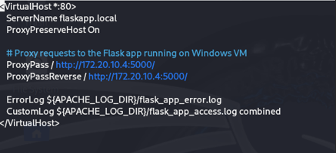

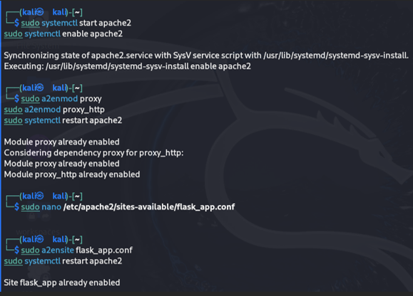

**For 2nd VM:**







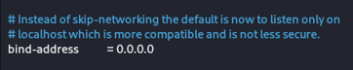



**3rd VM:**

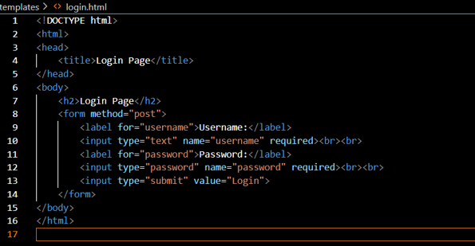

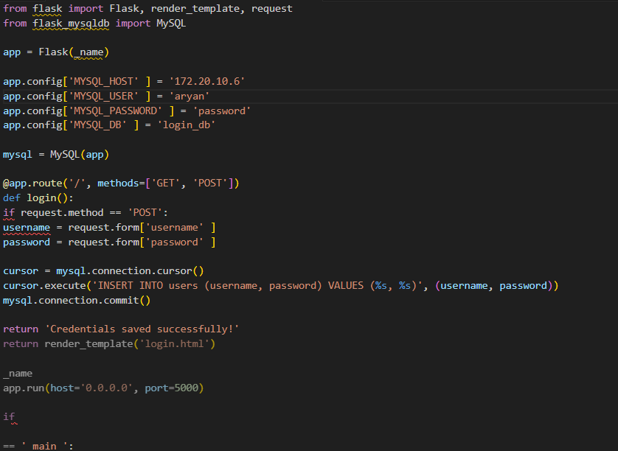

**5. Results and Analysis:**

**6. Conclusion:**

**• Setting up the application server on one machine and running the application on another can be challenging, but it can be achieved by using proxies and configuring the IP address of the machine hosting the application.**

**• To access the database server from anywhere on the network, update the bind address to 0.0.0.0 and create a user in the database with permissions tailored to their specific tasks.**

**7. References:**

* [**Apache mod_proxy Guide**](https://httpd.apache.org/docs/2.4/mod/mod_proxy.html)**.**